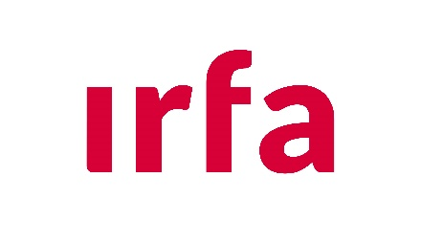 | Shooting of documents for film, television and/or any video for public distribution:  REQUEST FORM

Filming manager’s identity

SURNAME:
First name:
Home institution:
E-mail:

Nature and scope of filming (name of report, program, sponsor, broadcast terms and dates, etc.)

Procedure
All requests for filming must be addressed to both :
- IRFA management (contact@irfa.paris)
- And to the Communications Department of Missions étrangères de Paris (communication@missionsetrangeres.com)

IRFA management has 10 working days to respond to your request.
Filming in document storage areas is prohibited. Only IRFA areas open to the public may be used for filming, on request.

Identification of documents to be filmed
Storage department:
Archives | Image library / Audiovisuals | Asian library | Map library
1st request
Analysis:

IRFA response: Grant Reject
LEGEND:

2nd request
Analysis:

IRFA response: Grant Reject
LEGEND:

3rd request
Analysis:

IRFA response: Grant Reject
LEGEND:

4th request
Analysis:

IRFA response: Grant Reject
LEGEND:

5th request
Analysis:

IRFA response: Grant Reject
LEGEND:

6th request
Analysis:

IRFA response: Grant Reject
LEGEND:

7th request
Analysis:

IRFA response: Grant Reject
LEGEND:

8th request
Analysis:

IRFA response: Grant Reject
LEGEND:

9th request
Analysis:

IRFA response: Grant Reject
LEGEND:

10th request
Analysis:

IRFA response: Grant Reject
LEGEND:

Undertaking from filming manager
I, the undersigned,
formally undertake to use the images of documents shot at the IRFA only within the framework and conditions noted above and to systematically accompany them with the mention “©Institut de recherche France-Asie/MEP” and the legend indicated by the IRFA.

Date and signature:

Approval by the IRFA official (Date, signature and stamp)

